Abercrombie & Fitch

Stock Report Date: 31/10/25 | Ticker: ANF | Exchange:

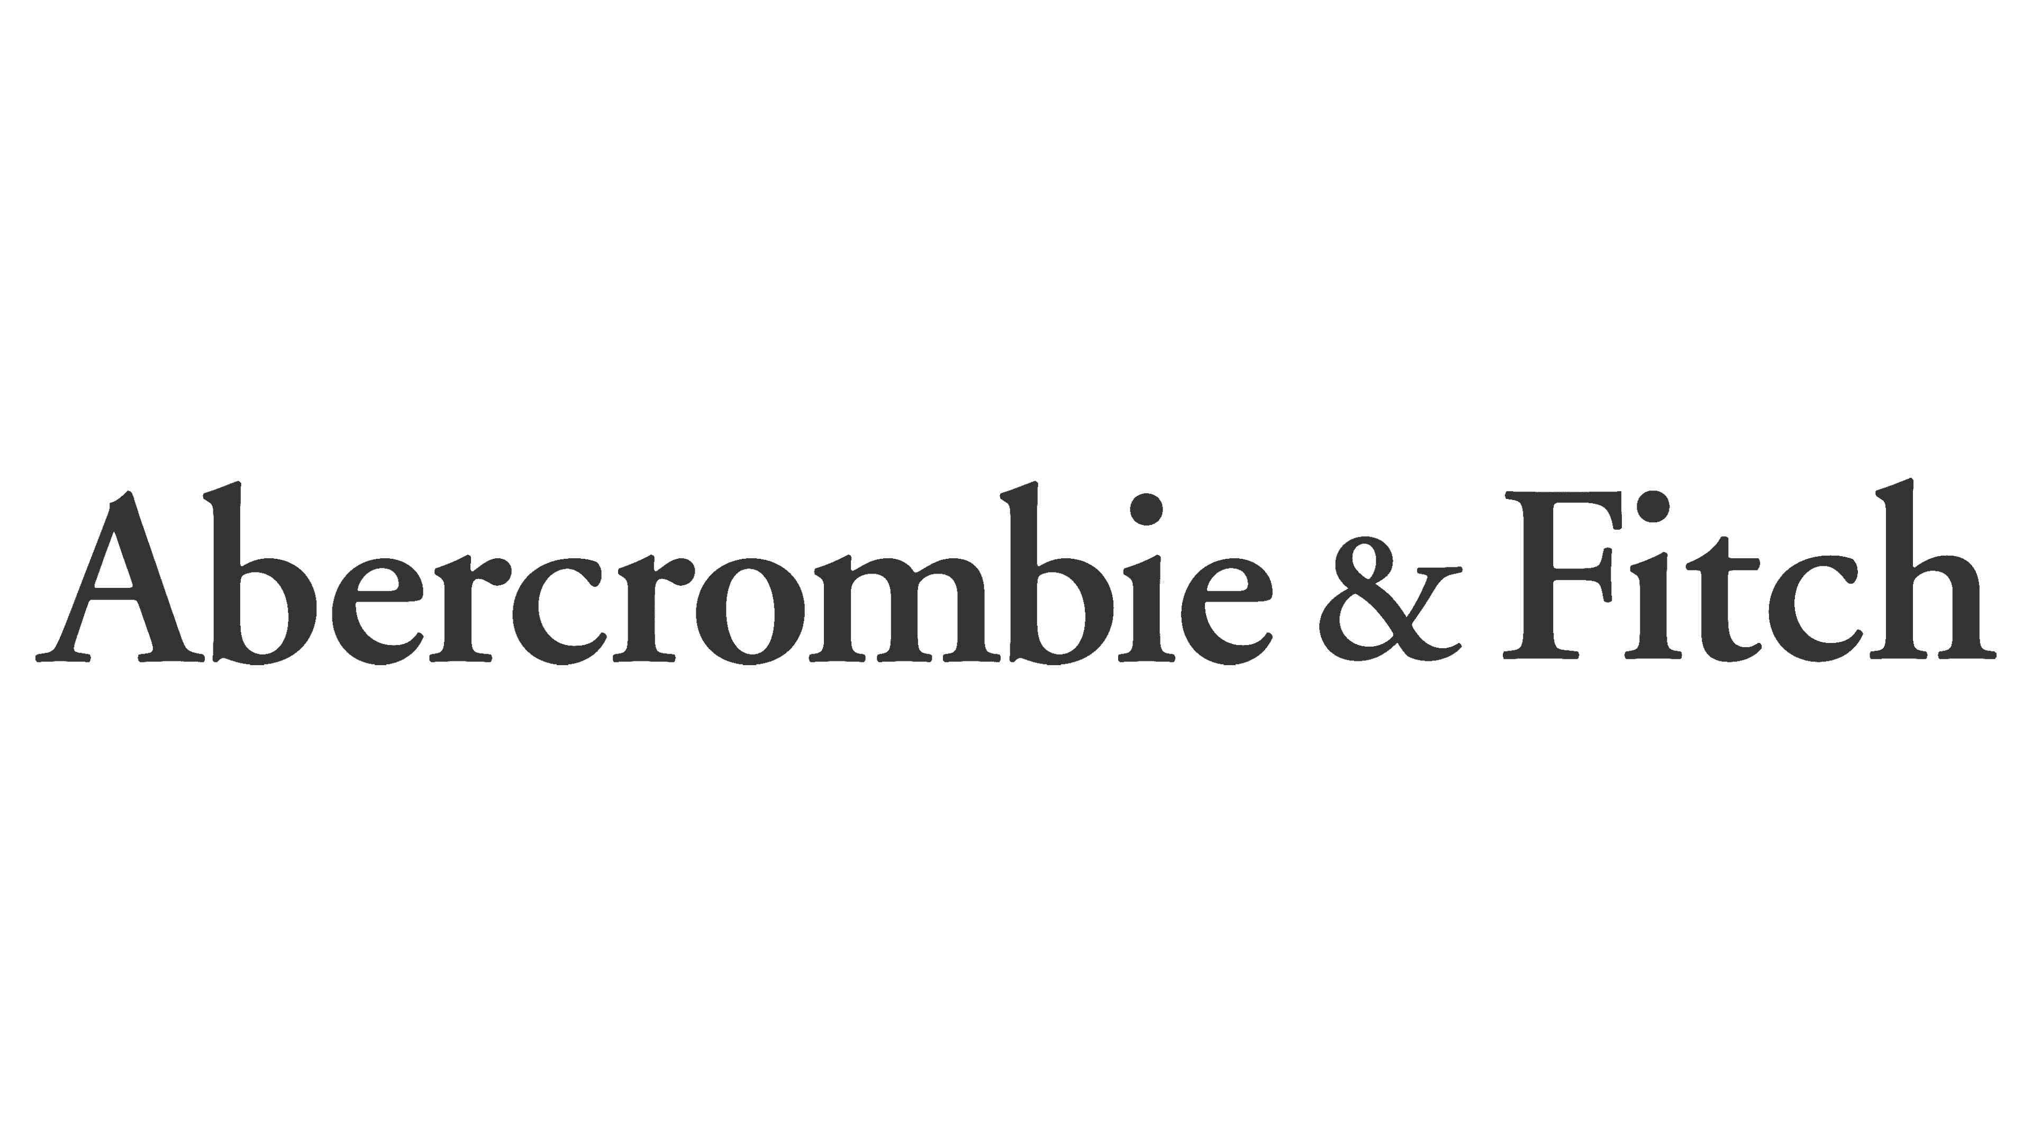

Stock Report: | Ticker: | Exchange:

## 

**Investment View: Strong Buy | Purchased at Price: 70.90 | Target Price : 114 | Target Upside: cece%**

## 

Stock Graph

Stock Info

## 

## 

## 

**Some Title**

Q2 Results

Abercrombie & Fitch delivered another strong quarter, marking its **11th consecutive quarter of growth** with **record 2Q net sales of $1.2bn, up 7% year over year**, and ahead of management’s prior outlook. Growth was driven primarily by **Hollister, which posted 19% net sales growth**, alongside continued strength in the **Americas (+8% YoY)** and **APAC (+12% YoY)**, partially offset by a modest **1% decline in EMEA**. Profitability was also strong, with a **reported operating margin of 17.1%** and **adjusted operating margin of 13.9%** excluding a **$39m pre-tax litigation settlement benefit**, both exceeding expectations. Adjusted EPS of **$2.32** compared favorably to prior guidance, underscoring effective cost control and operational discipline. Reflecting this momentum, management **raised full-year net sales growth guidance to 5–7%** and reaffirmed its long-term growth outlook, while incorporating an estimated **$90m tariff impact (~170 bps of sales)** into profitability assumptions, signaling confidence in the durability of brand demand and earnings power.

FY Guidance

For fiscal 2025, the company updated its full-year guidance and now expects **net sales growth of 5%–7%**, supported by continued store expansion and steady underlying demand. **Operating margin is projected in the range of 13.0%–13.5%**, reflecting disciplined cost control despite ongoing tariff-related pressures. The **effective tax rate is expected to be approximately 30%**. **Net income per diluted share is guided to $10.00–$10.50**, assuming a **diluted weighted average share count of approximately 49 million**. Capital allocation remains shareholder-friendly, with **approximately $400 million in share repurchases** planned for the year. The company expects **capital expenditures of approximately $225 million**, primarily to support store growth and maintenance. Real estate activity includes **approximately 40 net new store openings**, consisting of **60 new openings and 20 closures**, along with **around 40 remodels and right-sizing initiatives**, underscoring continued portfolio optimization.

Investment Thesis

## 

## 

## 

## 

## 

## 

## 

## 

## 

## 

**Company Summary**

Abercrombie & Fitch Co. is an American apparel retailer founded in Delaware in 1996. The company operates as a digitally led, omnichannel retailer, offering apparel, accessories, and personal care products for men, women, and children. Abercrombie & Fitch sells its products through a portfolio of brands, including Hollister, Gilly Hicks, Social Tourist, Abercrombie & Fitch, and Abercrombie Kids.

Each brand targets a distinct customer demographic. Hollister primarily focuses on teenagers, Gilly Hicks targets Generation Z consumers, and Social Tourist—co-created with influencers Charli and Dixie D’Amelio—is also aimed at Gen Z. The Abercrombie & Fitch brand targets young adults, primarily millennials, while Abercrombie Kids is designed for children. The company operates globally across the Americas, Europe, Asia-Pacific, the Middle East, and Africa.  
(Source: Abercrombie & Fitch Company Investor Relations)

## 

**Strategy**

Abercrombie & Fitch’s long-term strategy is centered on becoming a digitally led, omnichannel global apparel retailer, while maintaining flexibility amid near-term macroeconomic and geopolitical uncertainty. The company’s “Always Forward Plan,” announced in fiscal year 2022, outlines a multi-year roadmap aimed at delivering sustainable growth and long-term shareholder value. This strategy is anchored on three core pillars: brand growth, digital acceleration, and financial discipline.

Under this framework, management is focused on driving brand-specific growth initiatives. These include targeted marketing and store investments for the Abercrombie brand, refinement of Hollister’s product assortment and brand positioning to support renewed growth, and continued expansion of the Social Tourist brand through an evolved merchandise mix. In parallel, the company is executing an enterprise-wide digital transformation, including modernization of key data platforms, progress on a multi-year ERP and cloud migration, and enhancements to the digital and mobile customer experience across the shopping journey.

Financial discipline remains a key priority, with management emphasizing lean inventory management, flexible inventory chase capabilities, and a balanced approach to investment, cost control, and efficiency initiatives. Collectively, these efforts position the company to pursue profitable, long-term growth while maintaining operational agility in a dynamic retail environment.

**Company History**

Abercrombie & Fitch traces its origins to 1892, when David T. Abercrombie opened the company’s first store, originally named David T. Abercrombie Co., which specialized in hunting and fishing equipment. In 1900, Ezra Fitch, a prominent lawyer, purchased a stake in the company, and by 1904 the business was officially renamed Abercrombie & Fitch. Abercrombie resigned in 1907, and Fitch ceased involvement with the company in 1928.

During its early years, the company catered to notable figures, including President Theodore Roosevelt. In the 1940s, Abercrombie & Fitch became a major supplier of military uniforms for both men and women across all branches of the U.S. armed forces. Throughout the 1950s and 1960s, the company continued to expand its apparel offerings. By 1968, Abercrombie & Fitch reported approximately $28 million in sales and pretax earnings of $866,000.

The company’s financial performance began to deteriorate in the 1970s. By 1975, despite operating nine retail stores, Abercrombie & Fitch reported a loss of approximately $1 million. In 1976, the company filed for bankruptcy. In 1978, Oshman’s Sporting Goods of Houston, Texas acquired Abercrombie & Fitch and subsequently opened several stores under the brand, including its first location in Beverly Hills, California.

In 1988, The Limited acquired Abercrombie & Fitch from Oshman’s for $47 million. In 1992, Limited Brands hired Michael Jeffries, who later became known for reshaping the company’s marketing and branding strategy around a provocative and highly sexualized image. In 1996, Abercrombie & Fitch became a publicly traded company, listing on the New York Stock Exchange under the ticker symbol ANF.

Following its initial public offering, the brand gained significant popularity among teenagers, driven in part by its controversial marketing approach. In 1998, Abercrombie & Fitch was spun off from Limited Brands. That same year, the company launched Abercrombie Kids, targeting children aged 7 to 14. In 2000, the company introduced Hollister as a subsidiary brand.

Over the following years, the company pursued additional brand extensions, some of which were later discontinued. In 2004, Abercrombie & Fitch launched Ruehl No. 925, which ultimately closed in 2010. In 2008, the company introduced Gilly Hicks, an underwear and loungewear brand.

## 

**Backlash**

Abercrombie & Fitch became widely known for its controversial marketing campaigns under Michael Jeffries’ leadership. In a 2006 interview, Jeffries stated that sex appeal was central to the brand’s identity, noting that the company intentionally marketed to “cool, good-looking people” and excluded others from its target audience.

The company also faced several class-action lawsuits alleging racial discrimination. These lawsuits claimed that Abercrombie & Fitch engaged in discriminatory hiring practices by favoring white employees for customer-facing roles while relegating minority employees to back-of-house positions.

In 2014, Michael Jeffries stepped down as Chief Executive Officer. In 2017, Fran Horowitz was appointed CEO. Under her leadership, the company undertook a significant brand turnaround, culminating in record sales performance in 2024.

**Industry Overview**

**U.S. Apparel Retail / Specialty Apparel Sub-Industry Outlook (as of End-November 2025)**

The fundamental outlook for the U.S. specialty apparel retail sub-industry is **neutral**, reflecting a structurally mature sector that has become increasingly bifurcated between well-positioned operators and underperforming peers. While select best-in-class and value-oriented retailers continue to outperform, broader industry fundamentals remain constrained by macroeconomic headwinds, muted consumer confidence, and limited pricing power.

* Macroeconomic conditions continue to weigh on discretionary apparel spending. Consumer sentiment remains depressed, with the University of Michigan Consumer Sentiment Index registering **51.0 in November 2025**, a level well below pre-pandemic norms and near multi-year lows. This persistent weakness in consumer confidence disproportionately impacts discretionary categories such as apparel and fashion accessories, particularly among lower- and middle-income consumers.
* Inflation trends present a mixed backdrop for the industry. According to the U.S. Bureau of Labor Statistics, core CPI rose **3.0% year-over-year in September**, reflecting modest reacceleration in underlying inflation. However, apparel inflation remains subdued. The CPI for apparel declined marginally year-over-year, signaling continued promotional activity and limited ability for retailers to pass through cost increases to consumers.
* Cost pressures remain elevated across the industry, driven primarily by higher tariff rates following trade policy changes implemented in early April and rising production costs across key apparel-manufacturing regions in Asia. These pressures have emerged after several years during which global supply chain constraints had begun to ease, further limiting margin expansion opportunities for apparel retailers. At the same time, labor market conditions have softened. U.S. unemployment rose to **4.3% by August 2025**, up from **3.7% in January 2024**, while long-term unemployment increased to **1.9 million individuals**, exceeding pre-pandemic levels. Although the labor market remains broadly stable, this deterioration points to a weaker consumer environment that continues to constrain discretionary apparel demand.
* Despite these macroeconomic challenges, equity market performance within the apparel retail sub-industry has been resilient at times. As of **November 17, 2025**, the S&P Composite 1500 Apparel Retail Index was up approximately **12% year-to-date**, modestly trailing the broader S&P Composite 1500’s **13.2% gain**. Over a five-year period, the apparel retail index delivered a **14.4% compound annual growth rate**, outperforming the broader market’s **12.1% CAGR**, underscoring the outperformance of dominant off-price and operationally efficient retailers within an otherwise challenged sector.
* Looking ahead, industry growth is expected to remain modest. Forecasts from Inforum and the Interindustry Economic Research Fund project that the U.S. clothing stores industry will grow at a **2.6% CAGR between 2025 and 2029**, a pace below that of the broader U.S. economy. Growth remains constrained by elevated interest rates, high absolute price levels, and limited real income expansion. Real disposable income is projected to increase by **1.8% in 2025** and **1.6% in 2026**, levels insufficient to meaningfully stimulate discretionary apparel spending.
* Consumer behavior continues to evolve in ways that favor value-oriented retailers. Measures from both the University of Michigan Consumer Sentiment Index and the Conference Board Consumer Confidence Index indicate sustained consumer caution, with households increasingly prioritizing essential spending and lower-cost alternatives. As a result, demand for full-price, fashion-driven apparel remains under pressure, while off-price, discount, and value-focused retailers are better positioned to sustain demand and protect traffic.

* Operationally, apparel retailers have responded to this environment by adopting more conservative labor strategies. Data from the U.S. Bureau of Labor Statistics indicate that seasonal retail hiring has become leaner in the post-pandemic period, with retailers increasingly relying on existing staff and automation. Seasonal hiring in the retail sector is projected to fall below **500,000 positions in Q4 2025**, the lowest level since 2009, reflecting cautious sales expectations and continued emphasis on cost discipline.

Overall, the U.S. specialty apparel and broader apparel retail sub-industry at the end of November 2025 is characterized by **low growth, heightened competition, and ongoing structural change**. While macroeconomic pressures and shifting consumer preferences continue to challenge discretionary apparel demand, value-oriented, off-price, and digitally capable retailers remain positioned to outperform within a mature and increasingly polarized market.

**Main Competitors**

* **American Eagle Outfitters -** is a U.S.-based specialty apparel retailer focused on casual, everyday clothing for teens and young adults, with a strong emphasis on denim and lifestyle basics. The company operates primarily through its American Eagle and Aerie brands and leverages an omnichannel model that integrates physical stores and e-commerce to drive customer engagement and growth.
* **Gap Inc. -** is a global apparel retailer with a diversified brand portfolio that includes Gap, Old Navy, Banana Republic, and Athleta. The company serves a wide range of customer demographics, from value-oriented families to more premium and performance-focused consumers, and emphasizes brand segmentation, scale efficiencies, and a balanced mix of store-based and digital channels across international markets.
* **Uniqlo** - , a subsidiary of Fast Retailing, is a global apparel brand centered on functional, high-quality basics under its “LifeWear” philosophy. The brand targets a broad demographic with timeless, minimalist designs and emphasizes operational efficiency, fabric innovation, and large-format store concepts to support global expansion.
* **H&M -**  is a global fast-fashion retailer offering trend-driven apparel at accessible price points. The company targets a broad, fashion-conscious consumer base and operates an extensive international store network supported by e-commerce. Its business model emphasizes rapid product turnover, frequent assortment refreshes, and scale-driven sourcing efficiencies.
* **Zara** **-** , the flagship brand of Inditex, is a vertically integrated fast-fashion retailer known for its rapid design-to-shelf cycle. The brand targets style-conscious consumers seeking trend-aligned apparel and benefits from a highly responsive supply chain that enables limited production runs, fast inventory turnover, and reduced markdown risk.

## 

**Operations**

**Financial Statements**

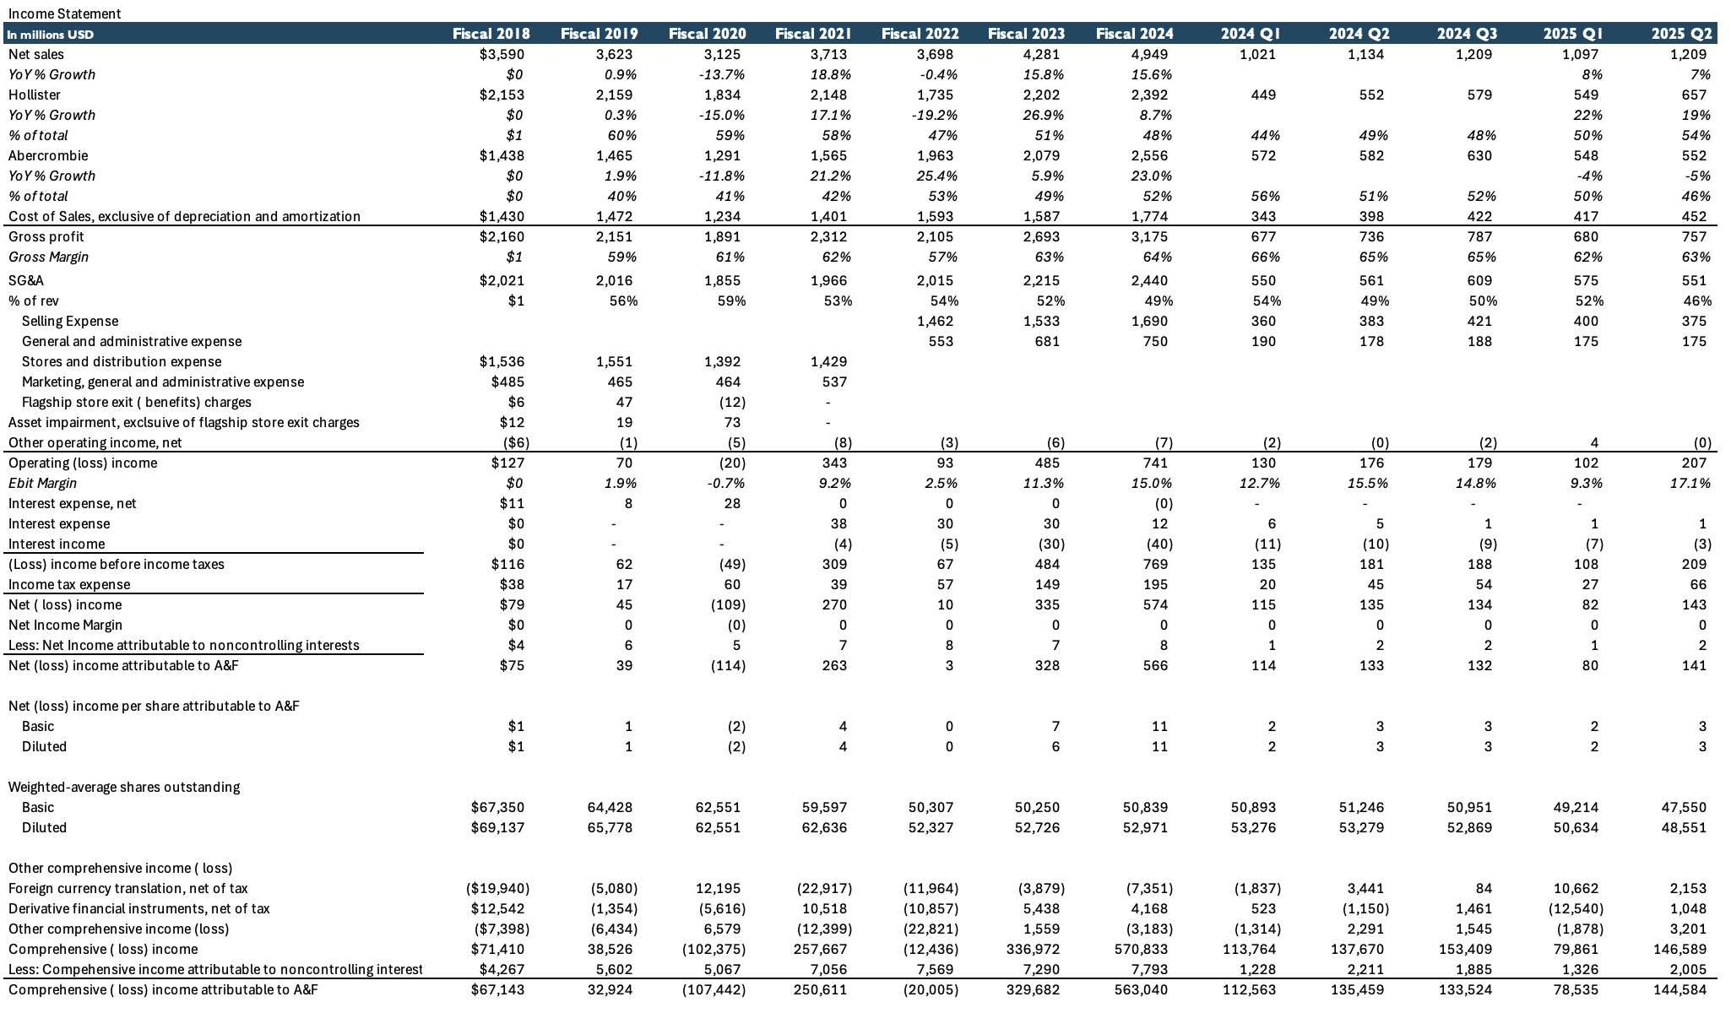

**Sales**

Since 2018 Abecrombie has experienced good growth, a CAGR of 5.1% for the respective years. They took a hit due to covid byt they were able to recover very quickly the following year. This growth has mainly been boosted by Abecrombie which has grown at a CAGR of 10.1% over the same period while Hollister has experienced a CAGR of 1.8%. In what has been of 2025 this growth trend has changed sightly. Hollister has become the biggest carrier of growth, growing 22% and 19% in Q1 and Q2 respectively while Abercrombie has seen a slight decline of 4% and 5% respectively. The growth that Hollister has seen has been mainly by increased sales in exisiting sales as we know why the increase in comprabale sales which has increased by 23% and 19% respectively. On the other hand, comprabale sales for Abercrombie have decrease more than the overall sales, seeing a decline of -10% and -11%. Why?

**Margins**

Over time, the company has demonstrated a clear improvement in profitability, with **gross margins expanding structurally** as pricing discipline, merchandising optimization, and supply chain efficiencies improved following the pandemic-related volatility. Gross margin recovered meaningfully after fiscal 2022 and has remained elevated, reflecting better inventory management and reduced promotional intensity.

Operating margins have followed a similar trajectory, with **EBIT margins expanding steadily** as SG&A leverage improved alongside revenue growth. While margins experienced short-term volatility on a quarterly basis due to seasonality and investment spending, the overall trend remains positive.

Net income margins have also strengthened over the long term, supported by higher operating profitability and improved cost control. **Most recently, margins remain healthy**, with gross margin in the low-to-mid 60% range and EBIT margin in the mid-teens, indicating sustained pricing power and a structurally more profitable business compared to historical levels

The sharp margin decline in Q1 2025 is largely seasonal, driven by post-holiday demand normalization, higher promotional activity, and front-loaded investment spending.

**ROTCE & ROIC Overtime**

* ROTCE= EBIT / ( NWC + NFA)
  + NWC = current assest ( exc. Cash) – current liabilities ( exc. Short term debt)
* ROIC = ( EBIT *(1-Tax Rate)) / ( ( Assets – Cash) – ( non – interest bearing current liabilities)

Abercrombie’s returns on capital deteriorated significantly between 2019 and 2020, reflecting weak operating performance, store rationalization, and pandemic-related disruptions. During this period, both ROTCE and ROIC reached trough levels as profitability declined and the capital base remained elevated.

From 2021 onward, returns rebounded sharply, driven by a meaningful recovery in EBIT, improved inventory discipline, and a structurally more efficient store footprint. The acceleration in 2023 and 2024 highlights strong operating leverage and improved capital allocation, as incremental investments generated significantly higher returns.

At current levels, both ROTCE and ROIC are well above historical averages, indicating that Abercrombie has successfully repositioned its business and is now generating returns meaningfully above its cost of capital.

**Valuation**

* Acquisitions Price
* Other Methodologies
* Other cases

Football field

Our target Price:

* Multiples
* Discunted Cash Flow

**Summary**

**Comparable Public Companies**

The comparable public company analysis implies a target price of approximately **$153**. This target price is derived using **average valuation multiples**, with **Winmark** excluded from the peer set due to its materially different business model and valuation profile relative to the other comparables.

While this implied valuation is modestly higher than the target price derived from the DCF analysis, it provides additional support for upside potential and suggests that the stock could perform slightly better than the DCF-only valuation would imply.

**Discounted Cash Flow Analysis**

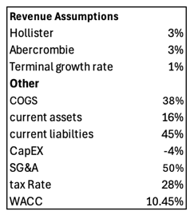

For the discounted cash flow analysis, I assume **revenue growth of 3%** for both the **Hollister** and **Abercrombie** brands. While Hollister has delivered strong performance this year, I adopt a conservative approach and do not assume that this elevated growth rate will persist over the next five years, particularly given the brand’s historically volatile growth profile.

Similarly, I apply a 3% growth assumption to the Abercrombie brand. Although I see meaningful long-term growth opportunities and view the recent decline in comparable sales as largely driven by a one-year inventory misstep rather than a structural issue, I believe a conservative growth rate is appropriate at this stage of the cycle.

Based on these assumptions, the DCF analysis results in a **target price of approximately $105 per share**.

**Sensitivity Analysis**

**Investment Thesis, Catalysts & Investments Risks**

**Investment Thesis**

I believe that over the past few years, the company has demonstrated a strong capacity to continue growing and capturing the interest of its target customers. I have confidence in its operational structure, which supports attractive margins and disciplined capital allocation. I believe the recent stock decline has been taken out of proportion, largely driven by investor concerns surrounding the Abercrombie brand and its transition from strong growth last year to a recent slowdown.

I remain confident that Abercrombie will continue to grow, even if it is currently experiencing a few weaker quarters. The company has meaningful growth opportunities through marketing initiatives, including its official partnership with the NFL. Additionally, it is one of the longest-standing American brands in the sector, demonstrating its ability to endure challenges and return to growth over multiple business cycles.

Management has also indicated that the decline in comparable sales was primarily driven by lower average revenue per customer rather than reduced store traffic. This was largely due to increased amount of products in promotion stemming from weaker inventory management in the prior year. Furthermore, Hollister has shown strong growth this year, and I expect this momentum to continue through the final two quarters of the year.

Lastly, my target price is not based on aggressive growth assumptions but rather on low single-digit growth expectations, which increases my confidence that the stock is currently undervalued.

**Investment Risks**

**Catalysts**

* I believe Q3 results could serve as a significant catalyst for the stock, particularly if continued strong growth at Hollister offsets the weaker performance of the Abercrombie brand this year. Additionally, a clearer explanation of the factors driving Abercrombie’s decline could support the stock, especially if management demonstrates that these pressures are cyclical rather than structural.
* New marketing initiatives, including collaborations with other companies or celebrities, could meaningfully influence broader fashion trends and strengthen Abercrombie’s positioning within the industry.
* Failure to maintain leadership within the sector by effectively aligning products with evolving customer wants and needs.
* Abercrombie is not positioned as a low-cost brand; therefore, any economic slowdown in the U.S. economy—particularly a significant event such as a recession—could materially impact demand and overall performance.
* Increased competition: While Abercrombie has performed well in core basic apparel categories, these segments are relatively easy to enter, and heightened competition could pressure margins and market share.
* Operational inefficiencies, such as renewed challenges in inventory management, could negatively affect both financial performance and stock valuation.